**Name:S.deva**

**192210100**

**EXP 12:Create a Virtual Machine with 1 CPU, 2GB RAM and 15GB storage disk using a Type 2 Virtualization Software.**

**Step1:create**

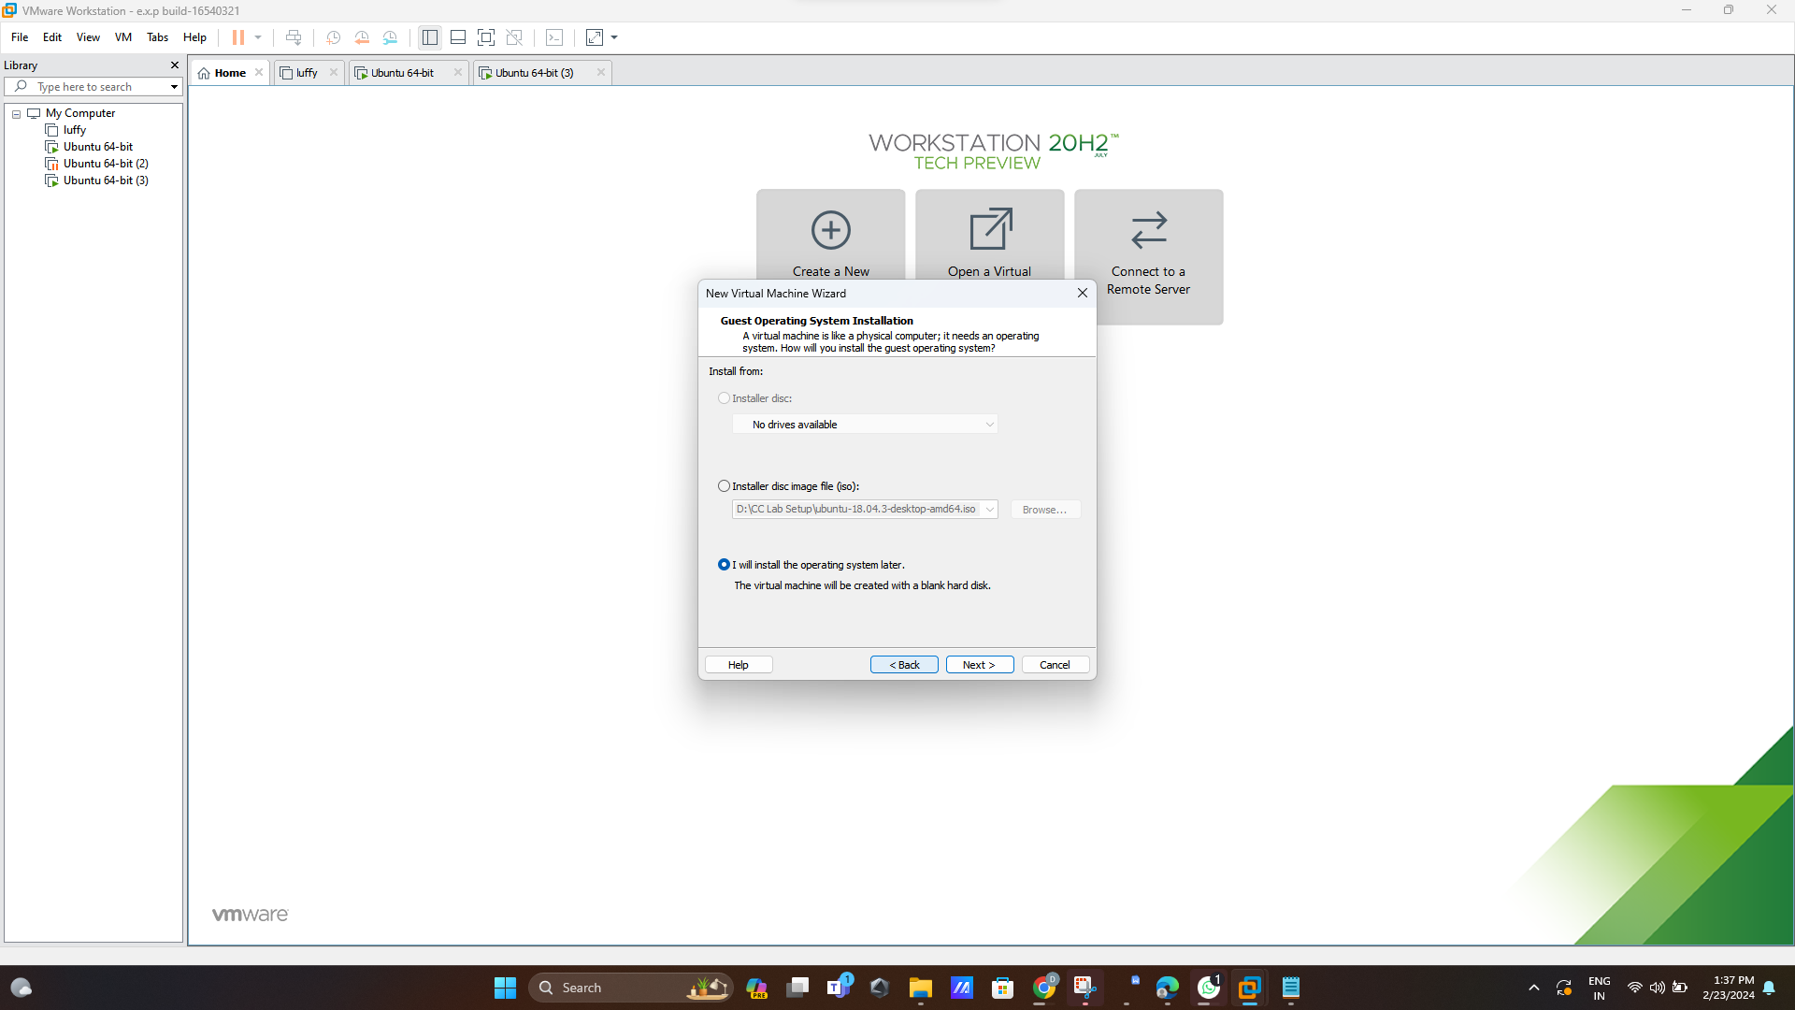

**Step 2:**

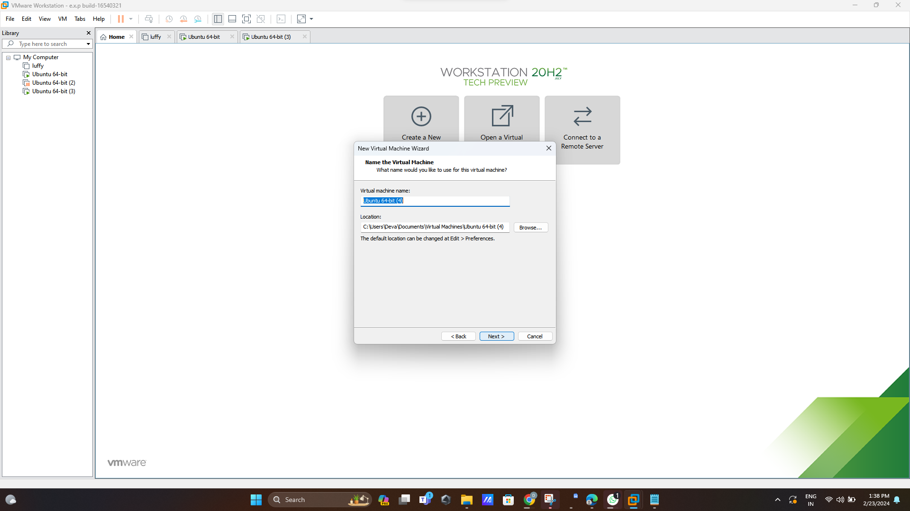

**Step 3:size 15GB**

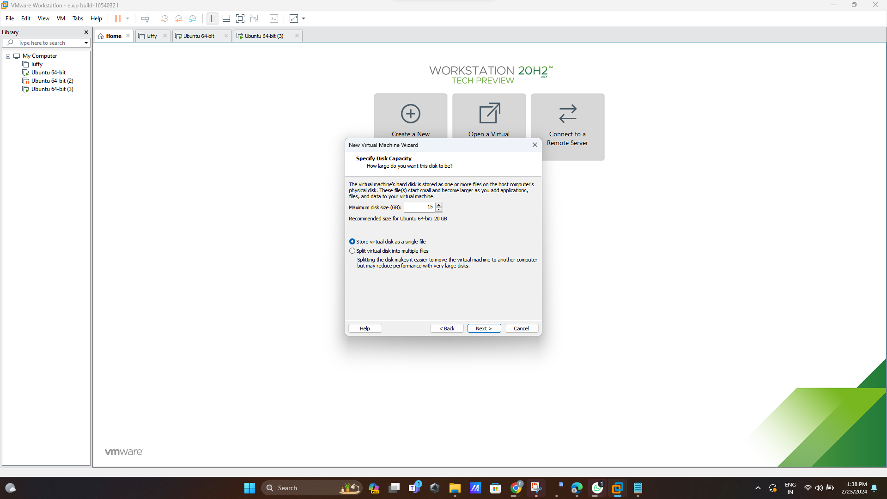

**Step 4:**

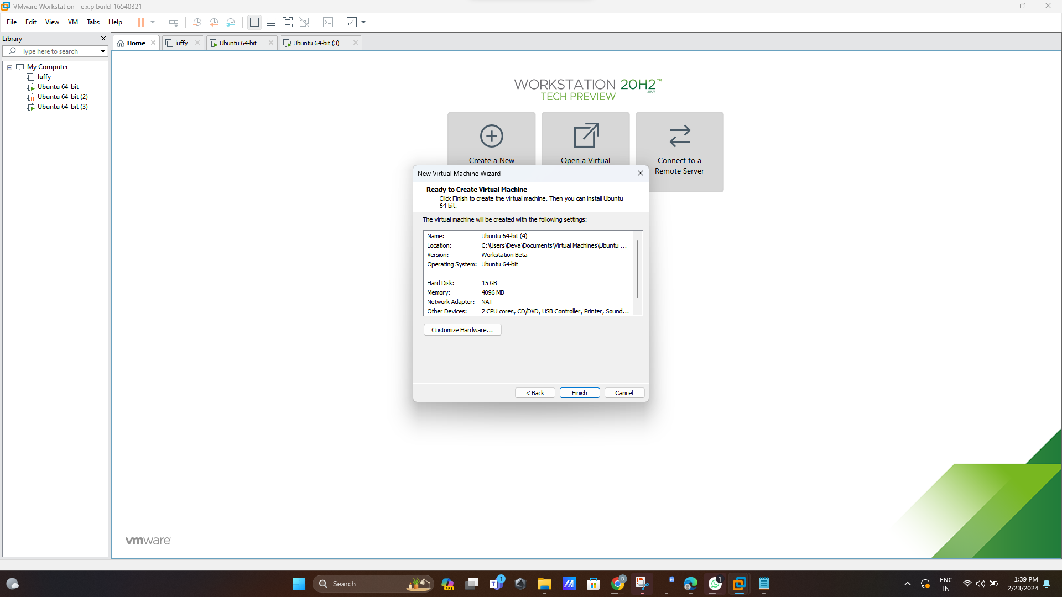

**Step 5:**

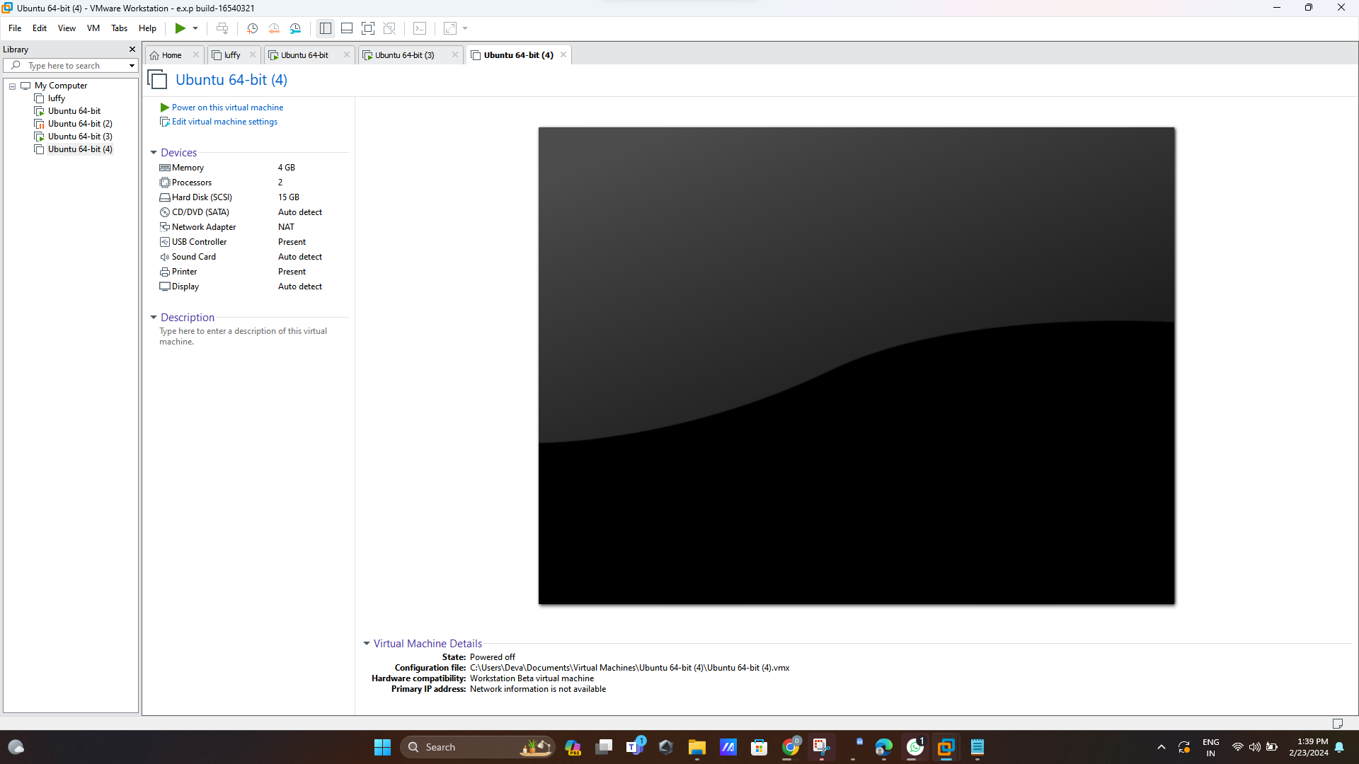

**Step 6:CLICK memory and change size**

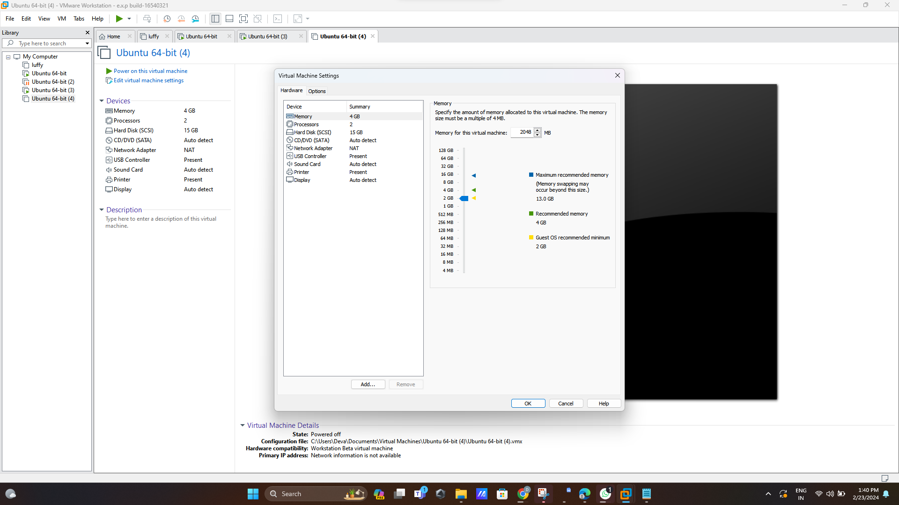

**Step 7:after changing size**

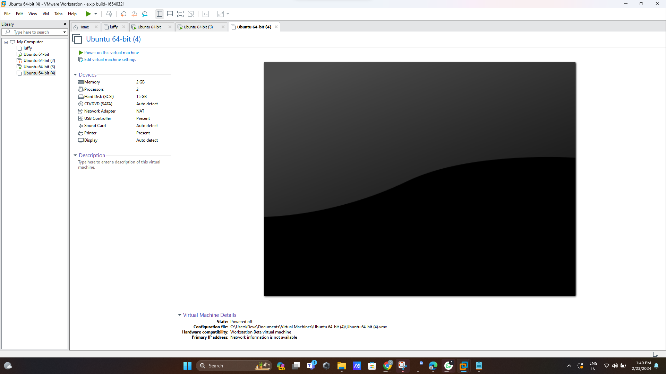

**Step 8:now change processors size**

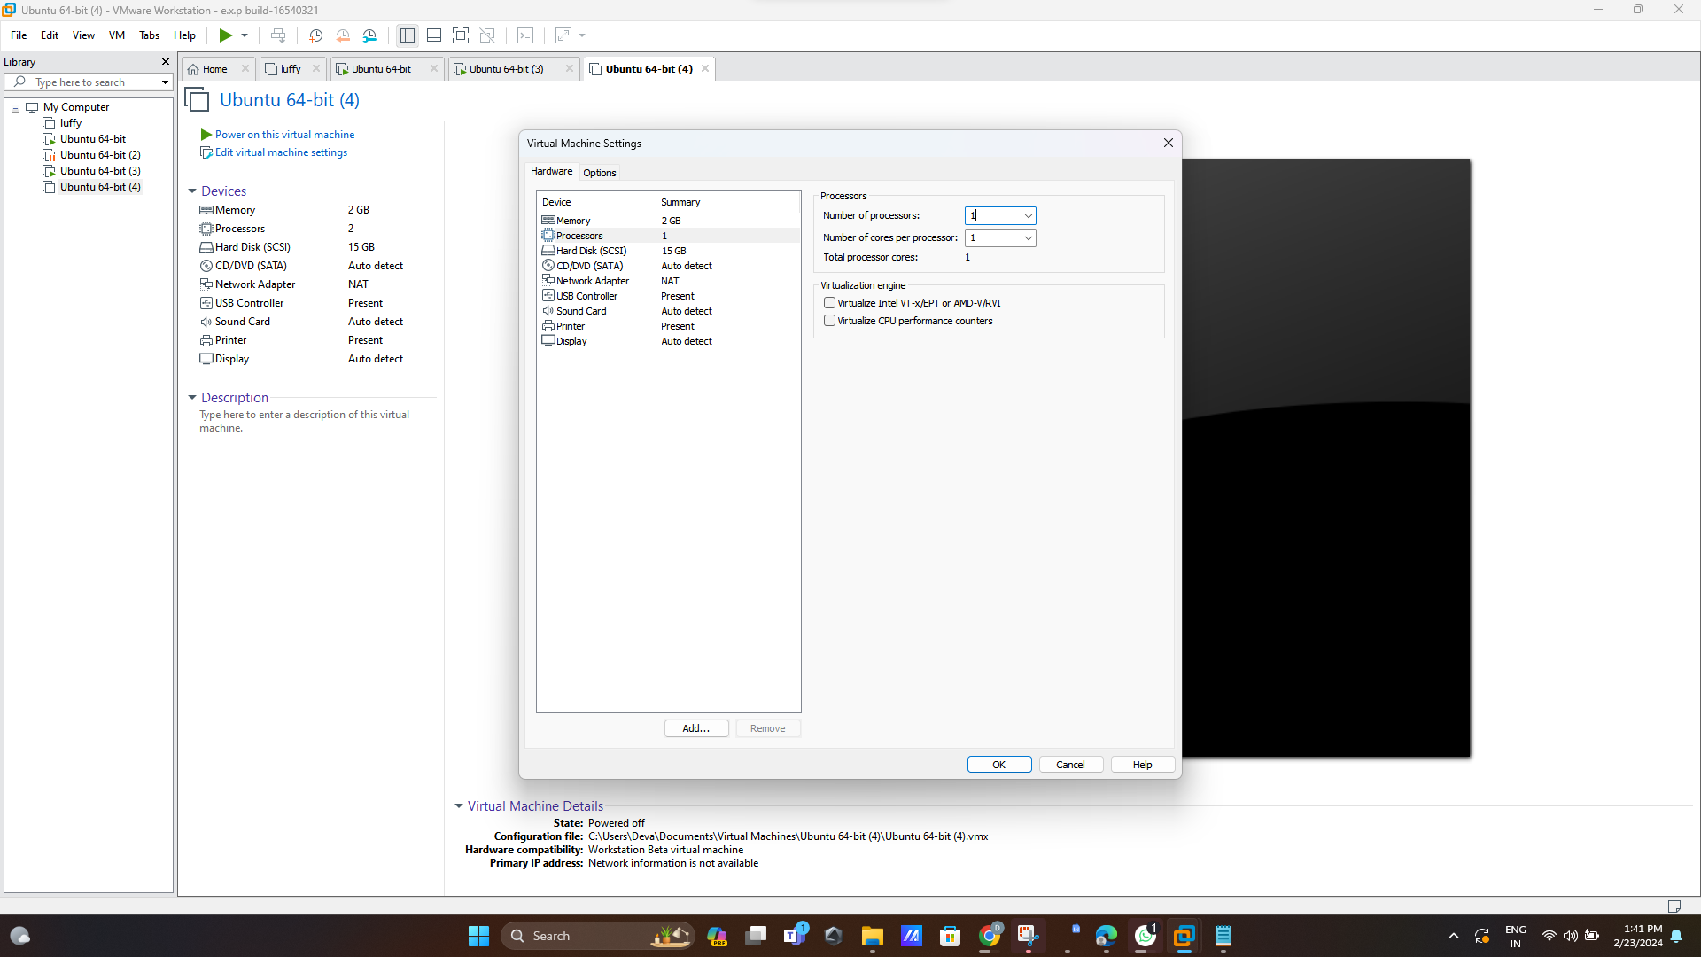

**Step 9:final output**

